**APP activity 3: postgresql**

**Name: Fiona DeMendonca**

Part 1) **Creating tables (should have four SQL query and four table views)**

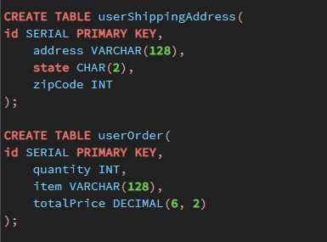

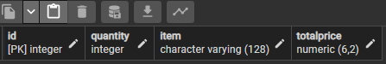

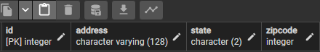

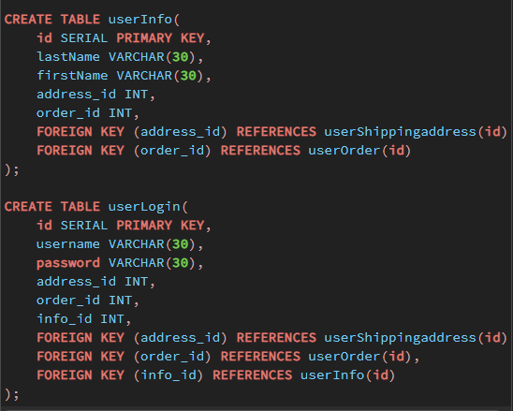

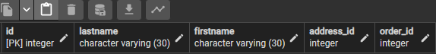

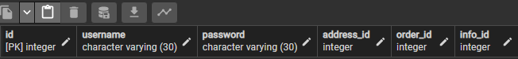

**Part 2) Entering data in each table (should have four SQL queries and four table views)**

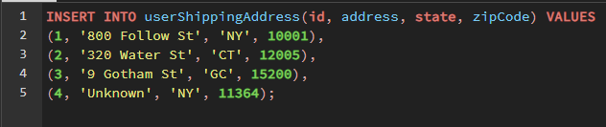

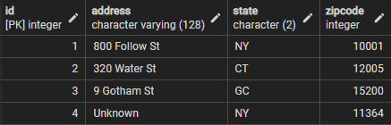

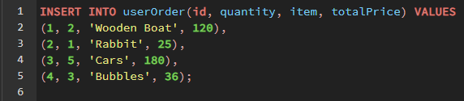

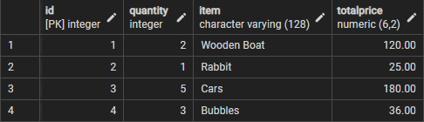

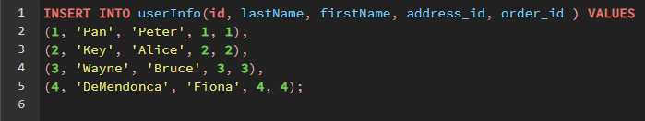

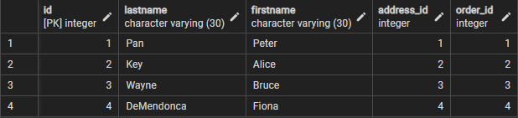

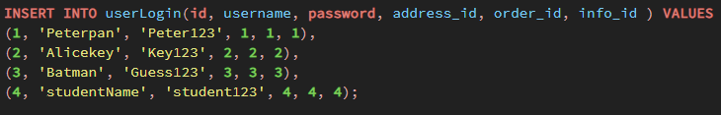

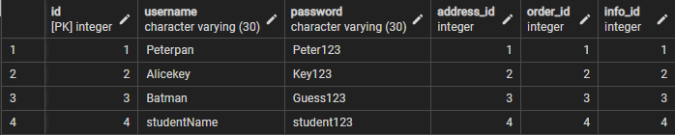

**Part 3) print data: (should have three SQL queries and three table views)**

